MACH4METAL

metalworking machinery
Transito 21
6909 DA BABBERICH Netherlands
Tel. +31 (0)316-247123
Fax: +31 (0)316-247956
info@mach4metal.com
www.mach4metal.com

Bank No : 66.52.13.883
IBAN : NL33 INGB 0665 2138 83
BIC : INGBNL2A

HEAVY DUTY 3 ROLL PLATE BENDER
FACCIN 3100 X 140 MM
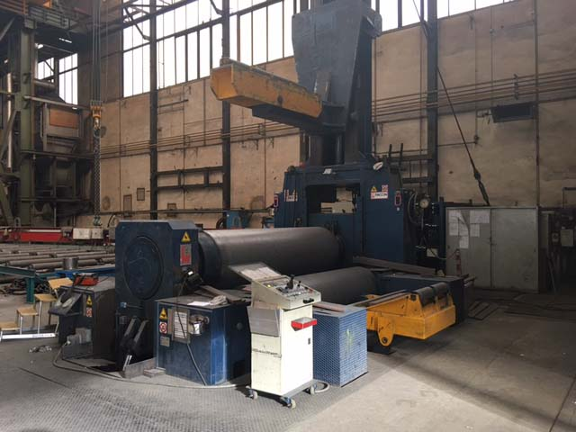
- Make : Faccin italia
- Typ : HAV / S 3190
- Serial No : 2931
- Age : 2006

- Rolling width : 3.050
- Between housing : 3.350

- Rolling thickness : 140 mm x R 2000
- Pre bending : 90 mm x R 2000
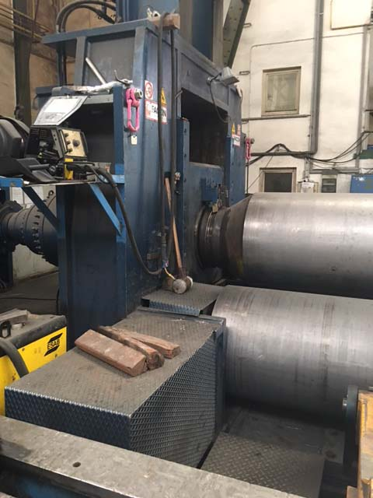
- Top roll Ø : 900
- Side roll Ø : 820

- Rolling speed : 2 – 4 M/min
- Power : 163 kW
- Adjustment top roll : 390 mm/Min
- Adjustment side roll : 700 mm/Min

- Top support load 25.000 Kg
- Side support load 8.000 kg ( double )
- Siemens Simatic variomatic / positioning
- Machine with various geometric each side roll can
Be positioned under power roll, ideal for different
Material thickness

- Length : 9.200
- Width : 5.450
- Height : 4.700
- Weight : 140.000 KG

Please Note: The above information has been obtained to the best of our ability and belief from, and from the manufacturers where possible. It is given in good faith, but its accuracy can not be guaranteed. Accordingly, it will not form a representation or constitute contractual terms. We advise you to check any vital details!
